***“*Internship at Elecon Engineering Co. Ltd.”**

**A Project Report**

**Submitted By**

**Rathod Chirag Ranjitsinh**

**Computer Engineering Department**

**Birla Vishvakarma Mahavidyalaya Vallabh Vidyanagar**

# Acknowledgement

I, Chirag Rathod, had the privilege of completing my internship at Tech Elecon Pvt. Ltd. under the valuable guidance of Mr. Satyam Raval. This internship provided me with a meaningful and enriching experience that significantly enhanced my practical skills in frontend development using React JS.

For an engineering student, an internship plays a significant role in strengthening practical knowledge and gaining exposure to industry standards and work environments.

I would like to express my deepest gratitude to all those who gave me the opportunity to complete this internship and supported me throughout the journey. I sincerely thank Mr. Satyam Raval for his consistent support, insightful feedback, and mentorship. His guidance helped me understand key frontend development concepts, effectively apply React, and follow best practices in component design, state management, and responsive UI development.

I also extend my gratitude to the entire team at Tech Elecon for their cooperation, technical support, and for fostering a collaborative work environment. Their professional approach and willingness to share knowledge helped me grow both technically and personally.

I look forward to applying the knowledge and skills gained during this internship to my future endeavors.

# To whom it may concern

This is to certify that Chirag Rathod, a student of Bachelor of Technology in Computer Engineering at Birla Vishvakarma Mahavidyalaya, has successfully completed his internship in the field of Frontend Development using React JS from 26/05/2025 to 26/06/2025 under the guidance of Mr. Satyam Raval, Deputy General Manager at Tech Elecon Pvt. Ltd.

His internship activities included the successful completion of the assigned project within the given timeframe, while adhering to the company's rules and regulations.

During the period of his internship program with us, he was exposed to various frontend development processes and was found to be diligent, hardworking, and eager to learn.

For Tech Elecon Pvt. Ltd.

# Index

Acknowledgement 2

TO WHOM IT MAY CONCERN 3

Index 4

Introduction 5

Implementation Details 6

1. Personal Portfolio Website 6

Tech Stack: 6

Key Features: 6

Implementation Highlights: 6

2. Udemy Clone – Frontend Project 6

Tech Stack: 6

Key Features: 6

Implementation Highlights: 7

3. Mini Projects and Learning Exercises 7

To solidify my React fundamentals, I developed various mini-projects: 7

Hooks and Patterns Used: 7

Summery 7

OVERVIEW OF THE COMPANY: 8

TOOLS AND TECHNOLOGIES 9

IMPLEMENTATION 10

REFERENCE 18

Conclusion 19

Key Takeaways 19

Final Thoughts 19

# Introduction

In the current era of web development, responsive and dynamic user interfaces have become essential to delivering seamless user experiences. With the increasing demand for interactive web applications, React JS has emerged as one of the most powerful libraries for building modern frontend interfaces. During my internship at Tech Elecon Pvt. Ltd., I focused on enhancing my skills in React JS through structured learning, hands-on practice, and real-world project development.

The internship began with foundational training, covering core concepts such as JSX, components, props, state, hooks, routing, and context API. I applied this knowledge through the development of multiple mini-projects, which included a background color changer, password generator, currency converter, and theme switcher. These projects helped me internalize the React workflow and component-based architecture.

As I progressed, I designed and developed a fully functional and visually appealing Personal Portfolio Website using React JS and Tailwind CSS. This project allowed me to explore responsive design patterns, custom UI components, and frontend deployment strategies. I also deployed the final portfolio at: https://chiragrathod.tech.

In addition, I worked on a Udemy Clone (Frontend Only), replicating the structure and features of modern e-learning platforms. This involved building routes for home, course listings, course details, user authentication pages, and dashboards — entirely through React and local state management.

The primary objective of this internship was to gain proficiency in frontend development using React JS and build production-level applications that follow industry-standard design principles. The experience not only improved my technical knowledge but also gave me valuable exposure to real-world UI/UX practices and collaborative development workflows.

# Implementation Details

During my internship at **Tech Elecon Pvt. Ltd.**, I worked on multiple React JS-based implementations following a modular and component-driven architecture. The goal was to strengthen my understanding of frontend development workflows by building real-world projects with scalable UI components, reusable logic, and responsive designs. Below are the core implementation details across the major projects:

## Personal Portfolio Website

## Tech Stack:

* **Frontend:** React JS, Tailwind CSS
* **Deployment:** Vercel, Custom Domain

## Key Features:

* Built fully responsive UI using Tailwind CSS utility classes
* Designed modular components for sections like About, Skills, Projects, and Contact
* Implemented theme switching (Dark/Light Mode) using Context API
* Hosted live site with custom domain: <https://chiragrathod.tech>

## Implementation Highlights:

* Component-based structure: Header, Footer, HeroSection, ProjectCard, Contact, Buy me a Coffee
* Used React Router for seamless navigation
* Integrated SEO-friendly titles, responsive breakpoints, and keyboard accessibility

## Udemy Clone – Frontend Project

## Tech Stack:

* React JS, Tailwind CSS, React Router
* Dummy data (local state only, no backend)

## Key Features:

* Home Page – Showcases featured courses and categories
* Course Listing Page – Grid display of available courses
* Course Detail Page – Detailed view with modules, ratings, and author info
* Authentication Pages – Static Login and Signup screens
* Cart and Dashboard – Basic layout for purchased/enrolled courses
* Video player page
* Instructor profile page
* User Course completion dashboard

## Implementation Highlights:

* React Router DOM was used to manage navigation and route-level views
* Applied responsive grid layouts and cards using Tailwind
* Handled reusable course data through props and local component state
* UI optimized for both desktop and mobile devices

## Mini Projects and Learning Exercises

## To solidify my React fundamentals, I developed various mini-projects:

* Prop Drilling Mini App: Demonstrated how props flow across nested components
* Password Generator: Included logic to generate strong passwords with character options
* Currency Converter: Integrated an open API to fetch real-time currency exchange rates
* Background Color Changer: Simple app to toggle page colors using state
* Theme Switcher: Used Context API to switch light/dark themes dynamically

## Hooks and Patterns Used:

* useState, useEffect, useContext, useRef, useCallback, etc
* Folder structure followed separation of concerns: components, assets, pages, routes, etc

## Summery

Each project was implemented using a modular and reusable approach, emphasizing code readability, UI consistency, and best practices in modern frontend development. I actively followed design inspirations from popular platforms and UI repositories like Mobbins to maintain a professional look and feel.

This internship allowed me to build production-ready frontend projects and significantly improve my understanding of React JS, component design, state management, and deployment workflows.

# Overview of the company

* Tech Elecon is the IT division of the Elecon group of companies and has an experience of more than 25 years in the field of hardware, software and networking solutions. Situated in the heart of Vitthal Udyognagar an Industrial Estate and in the proximity of the educational town of Vallabh Vidyanagar, Tech Elecon is all set to reach new heights in the field of IT solutions.
* Tech Elecon ready with all sorts of solutions and we deliver any application that is web based and further our solutions are designed to adapt your business rather than your business adapting the software. Tech Elecon solutions are 100% fruitful and empower you to take control of your business online and in real time!
* Tech Elecon provides OEM level products, packaged products, and ready to install systems for wireless Data and Voice for industrial, and military, and government clients.
* TEPL is one of the competent solution providers in the field of Information Technology. Our technical expertise make us accomplished to provide perfect and amicable solutions to all our clients IT related requirements.
* The expert analysts and consultants at TEPL work to provide with a comprehensive look of the entire IT landscape and also detailed perspective on client's key areas of concern. These can be in the form of feasibility studies, evaluations, implementation, and maintenance of various IT solutions.

# Tools and technologies

1. HTML / JSX (JavaScript XML)
   * In React, **JSX** is used to create HTML-like structures directly within JavaScript. This approach allows for the creation of modular, reusable components that render dynamic UIs. JSX helps maintain a clear and declarative structure of UI elements while enabling embedding of logic and interactivity directly within the component layout.
2. Tailwind CSS

* Tailwind CSS was used extensively for styling and layout purposes. Its utility-first classes allowed for rapid prototyping and responsive design implementation. From buttons and cards to full-page sections and themes, Tailwind CSS provided full control over spacing, colors, typography, and interactivity without writing custom CSS.
  + Created consistent and mobile-friendly UI layouts
  + Designed dark/light themes using utility classes
  + Implemented hover effects, transitions, and grid/flex layouts

1. React.js

React.js served as the core library for building the application's frontend:

* Component-Based Architecture: Developed reusable components like Navbar, Card, CourseList, PortfolioSection, etc.
* State Management: Used useState, useEffect, and useContext to manage application state across components
* Event Handling: Implemented dynamic behavior for UI elements (e.g., button clicks, form inputs, theme toggles)
* Routing: Used React Router DOM to handle client-side routing and navigation between pages
* Dynamic Rendering: Leveraged React’s virtual DOM to efficiently render only updated components, improving performance

1. Git & GitHub

* Used Git for version control and GitHub for hosting repositories and collaborating:
* Tracked daily progress and maintained project history
* Used feature branches to experiment with changes without affecting the main codebase
* Integrated GitHub Pages for deploying the portfolio website

1. Deployment Tools

* Vercel was used to deploy the personal portfolio website with a custom domain ([chiragrathod.tech](https://chiragrathod.tech))
* Learned about other hosting services (e.g., Vercel, Netlify) during deployment research
* Applied concepts of static site hosting, DNS configuration, and build pipelines.

# Implementation

* 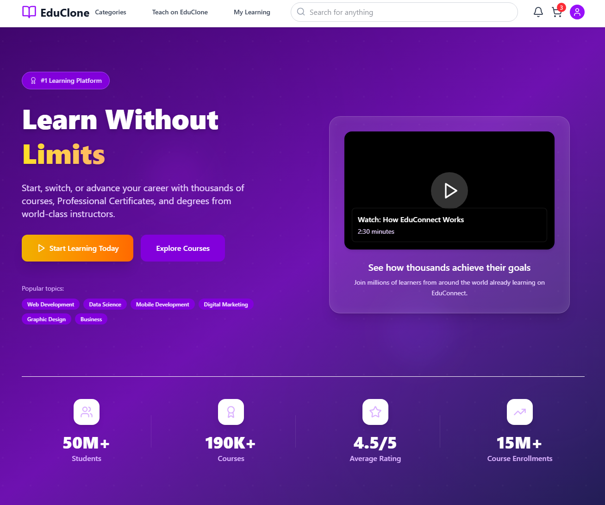Header and Hero section (Udemy clone project)
* Login Component (Udemy clone project)

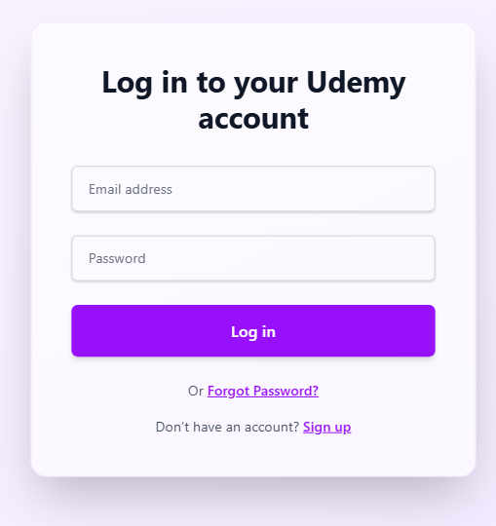

* Registration Component (Udemy clone project)

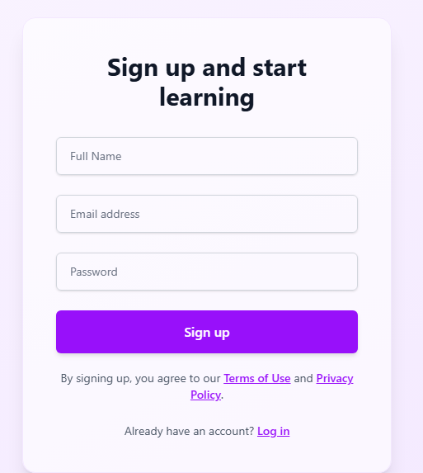

* Course Cards (Udemy clone project)

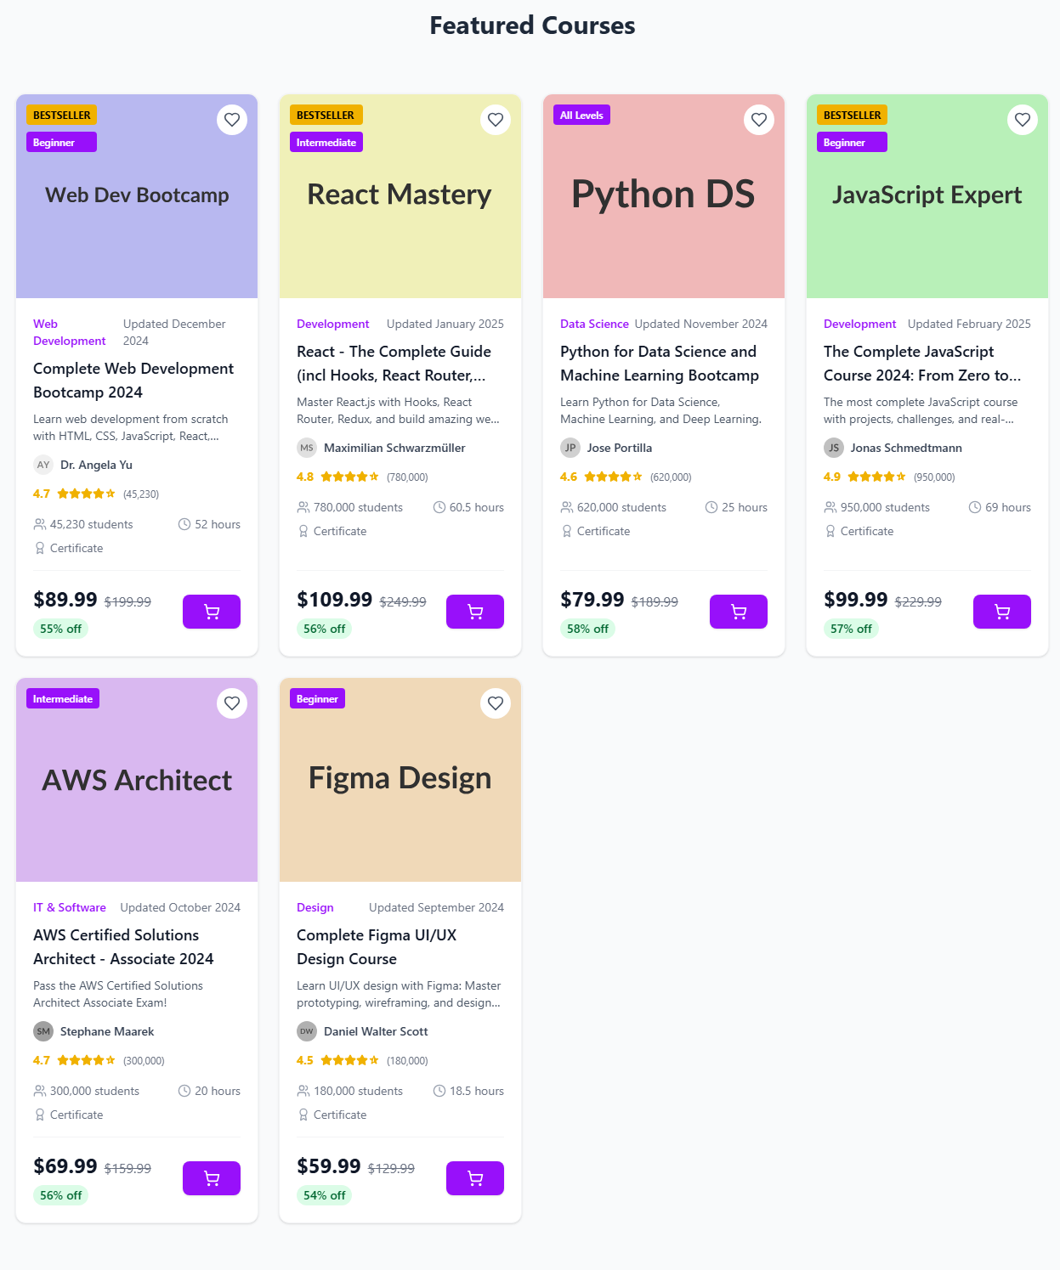

* Course Details (Udemy clone project)

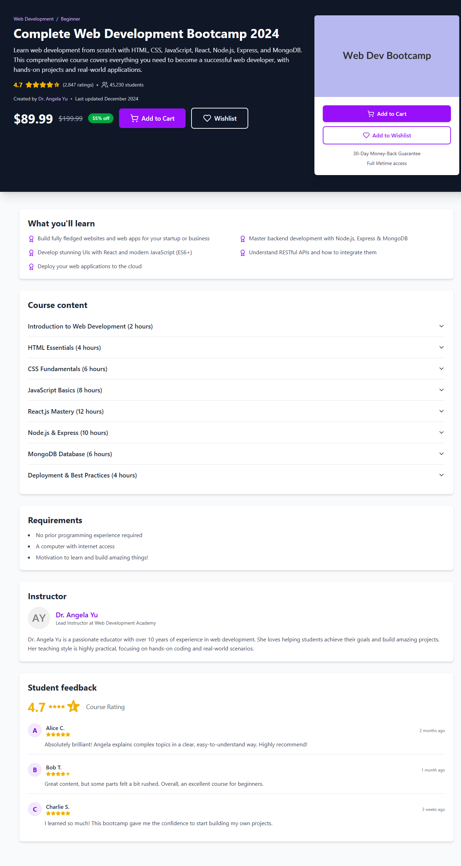

* Instructor Profile Page (Udemy clone project)

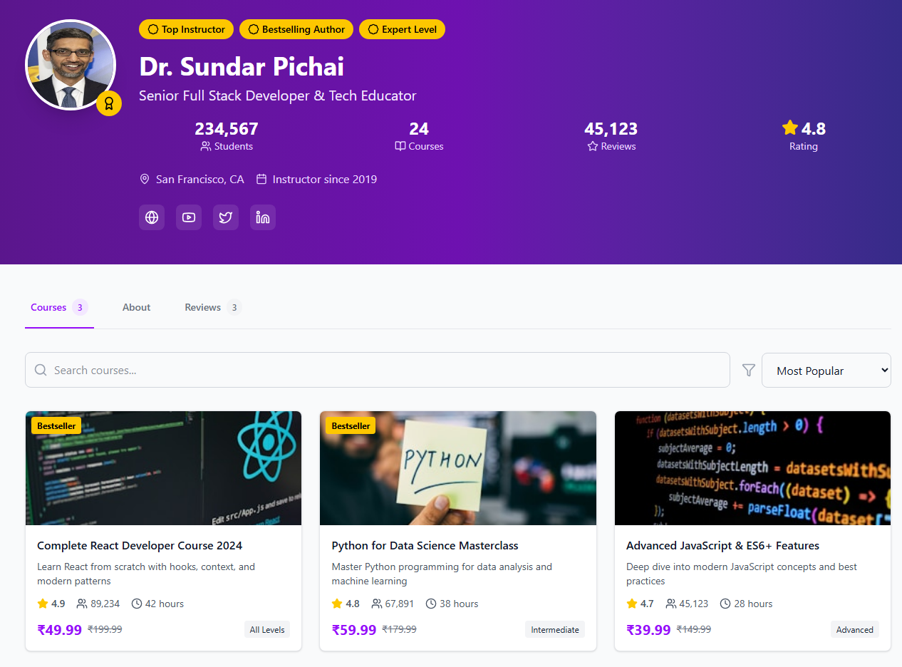

* Courses cart (Udemy clone project)

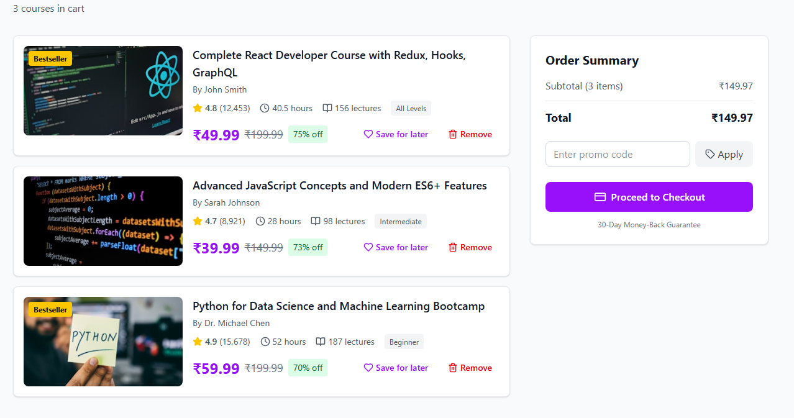

* 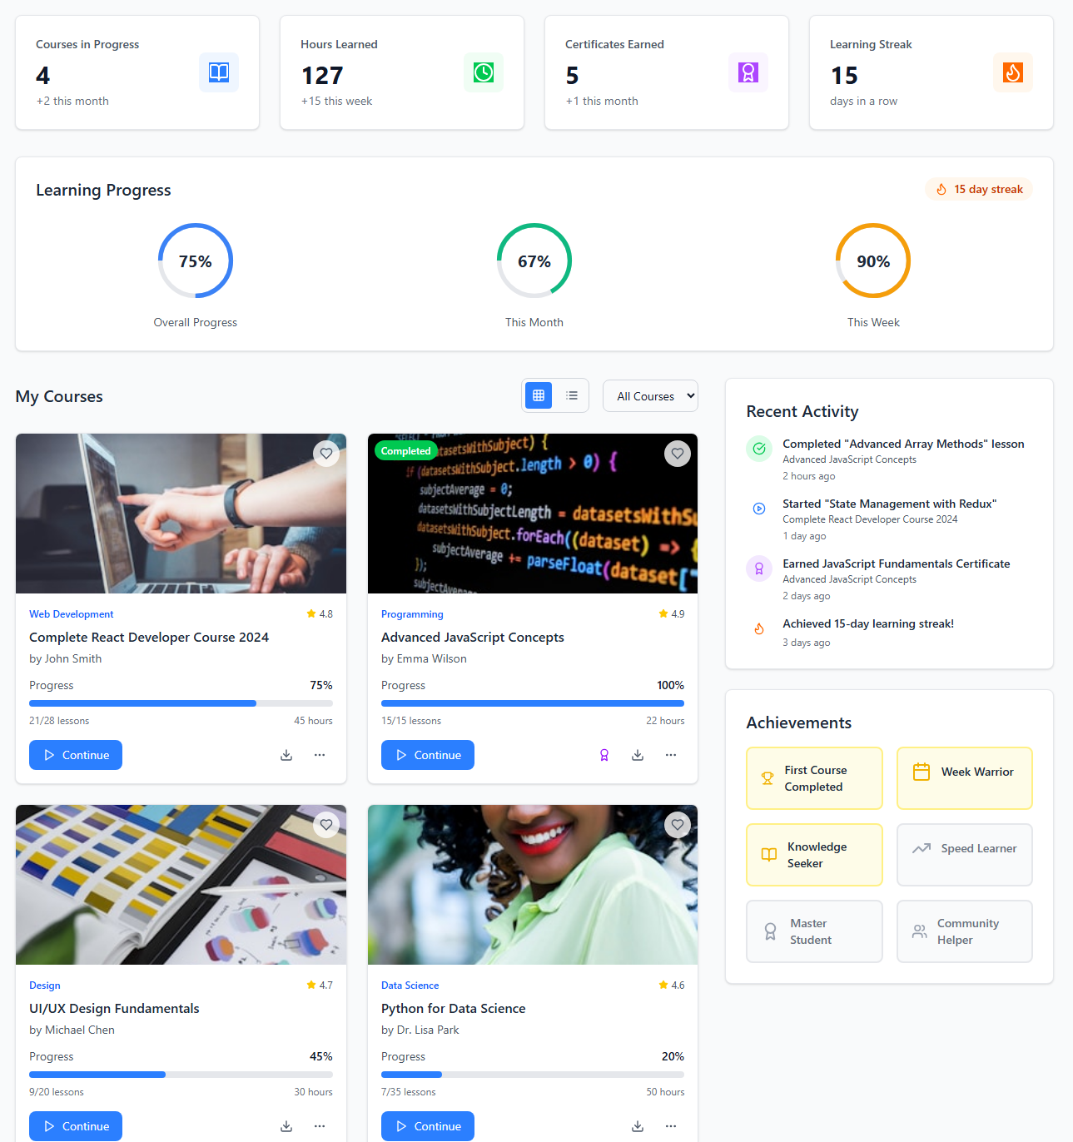User dashboard (Udemy clone project)
* 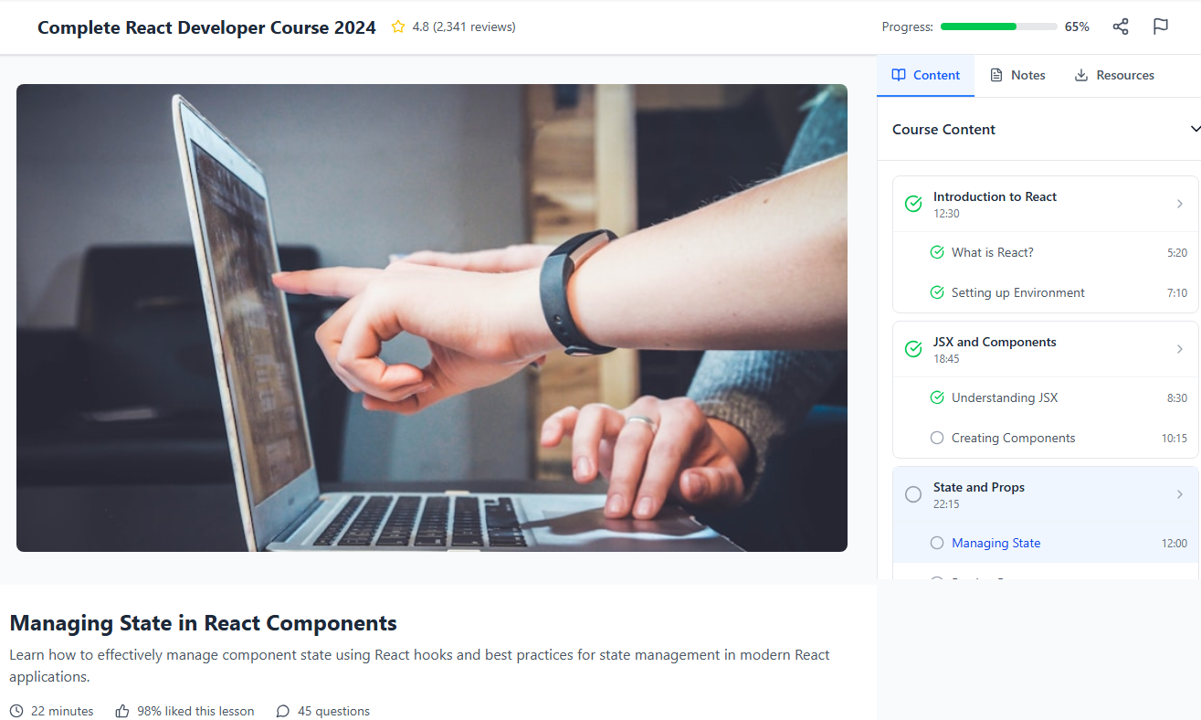Course player (Udemy clone Project)
* 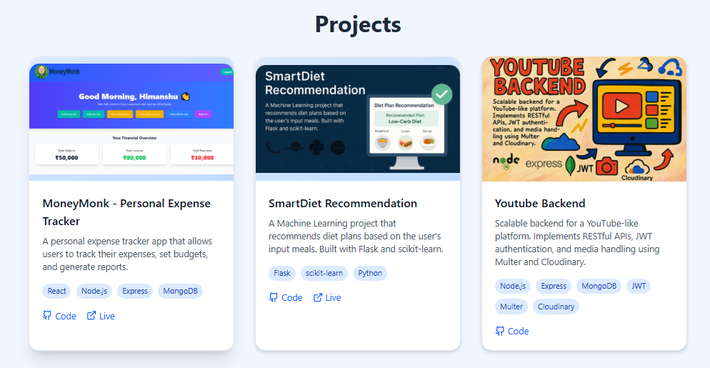Project Cards (Portfolio website project)
* Contact Form (Portfolio website project)

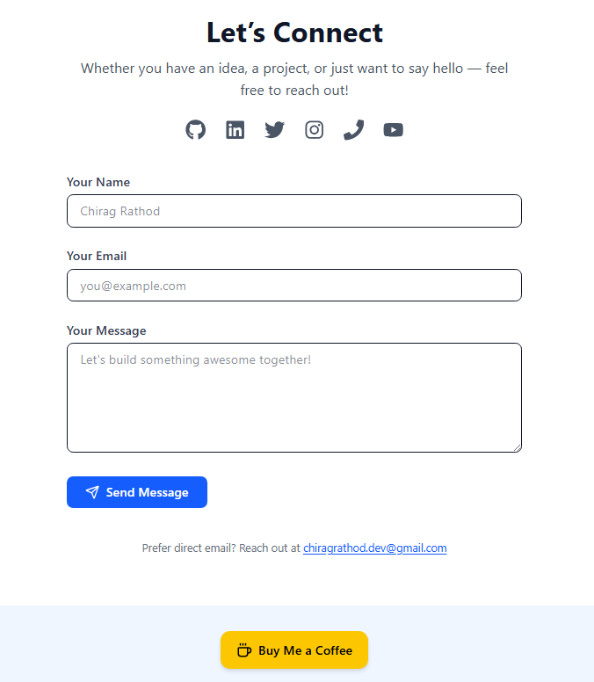

# Reference

* Hitesh Choudhary – Chai aur Code YouTube Series: https://www.youtube.com/@HiteshChoudhary
* React Official Documentation

https://reactjs.org

* Tailwind CSS Documentation

https://tailwindcss.com/docs

* React Router Documentation

https://reactrouter.com

* Git & GitHub Official Documentation

https://docs.github.com

* FreeCodeCamp Articles & Tutorials

https://www.freecodecamp.org

* W3Schools – React & JavaScript Tutorials

https://www.w3schools.com

* Mobbins – UI Inspiration for Web Design

https://mobbin.com

* JavaScript Info – Deep Dive into JS Concepts

https://javascript.info

* Stack Overflow – Community Solutions and Debugging

https://stackoverflow.com

* GitHub Pages – Free Hosting for Static Sites

https://pages.github.com

# Conclusion

My internship at Tech Elecon Pvt. Ltd. provided a practical and immersive experience in frontend web development using React JS. Throughout the internship, I was able to strengthen my theoretical understanding of React and apply it to real-world projects and interfaces. The hands-on learning approach helped me become proficient in component-based development, responsive design, state management, and frontend deployment workflows.

## Key Takeaways

* Modern Frontend Development with React JS
  + React’s component-based architecture enabled the development of modular, reusable, and interactive UI components. I implemented various features such as dark/light theme toggles, routing systems, form handling, and data rendering in projects like my personal portfolio and Udemy clone.
* Responsive and Scalable Styling with Tailwind CSS
  + Using Tailwind CSS, I was able to build highly responsive layouts and customize design elements efficiently. It provided full control over spacing, colors, and responsiveness, reducing the need for custom CSS and accelerating development time.
* Project Deployment and Version Control
  + I deployed my portfolio website using GitHub Pages and configured a custom domain, gaining practical exposure to deployment processes. Additionally, using Git & GitHub helped in tracking versions, backing up code, and managing project milestones professionally.
* Continuous Learning and Mini Projects
  + Throughout the internship, I engaged in continuous learning via online resources like Chai aur Code by Hitesh Choudhary and applied those learnings in projects.

## Final Thoughts

This internship served as a critical stepping stone in my journey as a frontend developer. I not only learned how to write clean and efficient React code but also understood the importance of UI/UX, responsive design, and code maintainability. Working in a semi-professional environment introduced me to real-world project structures, design systems, and development best practices.

The successful implementation of multiple projects during the internship has prepared me to take on more advanced frontend challenges in future roles. It has laid a solid foundation for building scalable and user-centric applications, and I am confident in applying this experience to professional full-stack development environments going forward.